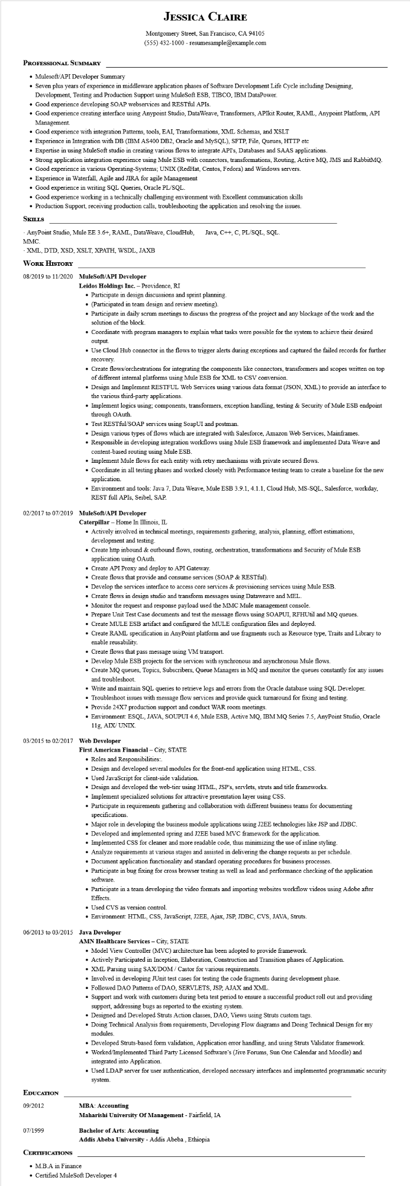
JESSICA CLAIRE
Montgomery Street, San Francisco, CA 94105 (555) 432-1000 - resumesample@example.com
PROFESSIONAL SUMMARY
• Mulesoft/API Developer Summary
• Seven plus years of experience in middleware application phases of Software Development Life Cycle including Designing, Development, Testing and Production Support using MuleSoft ESB, TIBCO, IBM DataPower.
• Good experience developing SOAP webservices and RESTful APIs.
• Good experience creating interface using Anypoint Studio, DataWeave, Transformers, APIkit Router, RAML, Anypoint Platform, API Management.
• Good experience with integration Patterns, tools, EAI, Transformations, XML Schemas, and XSLT
• Experience in Integration with DB (IBM AS400 DB2, Oracle and MySQL), SFTP, File, Queues, HTTP etc
• Expertise in using MuleSoft studio in creating various flows to integrate API's, Databases and SAAS applications.
• Strong application integration experience using Mule ESB with connectors, transformations, Routing, Active MQ, JMS and RabbitMQ.
• Good experience in various Operating-Systems; UNIX (RedHat, Centos, Fedora) and Windows servers.
• Experience in Waterfall, Agile and JIRA for agile Management
• Good experience in writing SQL Queries, Oracle PL/SQL.
• Good experience working in a technically challenging environment with Excellent communication skills
• Production Support, receiving production calls, troubleshooting the application and resolving the issues.
SKILLS
AnyPoint Studio, Mule EE 3.6+, RAML, DataWeave, CloudHub, Java, C++, C, PL/SQL, SQL. MMC.
XML, DTD, XSD, XSLT, XPATH, WSDL, JAXB
WORK HISTORY
08/2019 to 11/2020 MuleSoft/API Developer
Leidos Holdings Inc. - Providence, RI
• Participate in design discussions and sprint planning.
⚫ (Participated in team design and review meeting).
• Participate in daily scrum meetings to discuss the progress of the project and any blockage of the work and the solution of the block.
• Coordinate with program managers to explain what tasks were possible for the system to achieve their desired output.
• Use Cloud Hub connector in the flows to trigger alerts during exceptions and captured the failed records for further recovery.
• Create flows/orchestrations for integrating the components like connectors, transformers and scopes written on top of different internal platforms using Mule ESB for XML to CSV conversion.
• Design and Implement RESTFUL Web Services using various data format (JSON, XML) to provide an interface to the various third-party applications.
• Implement logics using; components, transformers, exception handling, testing & Security of Mule ESB endpoint through OAuth
• Test RESTful/SOAP services using SoapUI and postman.
• Design various types of flows which are integrated with Salesforce, Amazon Web Services, Mainframes.
• Responsible in developing integration workflows using Mule ESB framework and implemented Data Weave and content-based routing using Mule ESB.
• Implement Mule flows for each entity with retry mechanisms with private secured flows.
• Coordinate in all testing phases and worked closely with Performance testing team to create a baseline for the new application.
• Environment and tools: Java 7, Data Weave, Mule ESB 3.9.1, 4.1.1, Cloud Hub, MS-SQL, Salesforce, workday, REST full APIs, Seibel, SAP.
02/2017 to 07/2019 MuleSoft/API Developer
Caterpillar - Home In Illinois, IL
• Actively involved in technical meetings, requirements gathering, analysis, planning, effort estimations, development and testing.
• Create http inbound & outbound flows, routing, orchestration, transformations and Security of Mule ESB application using OAuth.
• Create API Proxy and deploy to API Gateway.
• Create flows that provide and consume services (SOAP & RESTful).
• Develop the services interface to access core services & provisioning services using Mule ESB.
• Create flows in design studio and transform messages using Dataweave and MEL.
• Monitor the request and response payload used the MMC Mule management console.
• Prepare Unit Test Case documents and test the message flows using SOAPUI, RFHUtil and MQ queues.
• Create MULE ESB artifact and configured the MULE configuration files and deployed.
• Create RAML specification in AnyPoint platform and use fragments such as Resource type, Traits and Library to enable reusability.
• Create flows that pass message using VM transport.
• Develop Mule ESB projects for the services with synchronous and asynchronous Mule flows.
• Create MQ queues, Topics, Subscribers, Queue Managers in MQ and monitor the queues constantly for any issues and troubleshoot.
• Write and maintain SQL queries to retrieve logs and errors from the Oracle database using SQL Developer.
• Troubleshoot issues with message flow services and provide quick turnaround for fixing and testing.
• Provide 24X7 production support and conduct WAR room meetings.
• Environment: ESQL, JAVA, SOUPUI 4.6, Mule ESB, Active MQ, IBM MQ Series 7.5, AnyPoint Studio, Oracle 11g, AIX/UNIX
03/2015 to 02/2017 Web Developer
First American Financial - City, STATE
• Roles and Responsibilities:.
• Design and developed several modules for the front-end application using HTML, CSS.
• Used JavaScript for client-side validation.
• Design and developed the web-tier using HTML, JSP's, servlets, struts and title frameworks.
• Implement specialized solutions for attractive presentation layer using CSS.
• Participate in requirements gathering and collaboration with different business teams for documenting specifications.
• Major role in developing the business module applications using J2EE technologies like JSP and JDBC.
• Developed and implemented spring and J2EE based MVC framework for the application.
• Implemented CSS for cleaner and more readable code, thus minimizing the use of inline styling.
• Analyze requirements at various stages and assisted in delivering the change requests as per schedule.
• Document application functionality and standard operating procedures for business processes.
• Participate in bug fixing for cross browser testing as well as load and performance checking of the application software.
• Participate in a team developing the video formats and importing websites workflow videos using Adobe after Effects.
• Used CVS as version control.
• Environment: HTML, CSS, JavaScript, J2EE, Ajax, JSP, JDBC, CVS, JAVA, Struts.
06/2013 to 03/2015 Java Developer
EDUCATION
09/2012
AMN Healthcare Services - City, STATE
• Model View Controller (MVC) architecture has been adopted to provide framework.
• Actively Participated in Inception, Elaboration, Construction and Transition phases of Application.
• XML Parsing using SAX/DOM/ Castor for various requirements.
• Involved in developing JUnit test cases for testing the code fragments during development phase.
• Followed DAO Patterns of DAO, SERVLETS, JSP, AJAX and XML.
• Support and work with customers during beta test period to ensure a successful product roll out and providing support, addressing bugs as reported to the existing system.
• Designed and Developed Struts Action classes, DAO, Views using Struts custom tags.
• Doing Technical Analysis from requirements, Developing Flow diagrams and Doing Technical Design for my modules.
• Developed Struts-based form validation, Application error handling, and using Struts Validator framework.
• Worked/Implemented Third Party Licensed Software's (Jive Forums, Sun One Calendar and Moodle) and integrated into Application.
• Used LDAP server for user authentication, developed necessary interfaces and implemented programmatic security system.
MBA: Accounting
Maharishi University Of Management - Fairfield, IA
07/1999
CERTIFICATIONS
Bachelor of Arts: Accounting
• M.B.A in Finance
Addis Abeba University - Addis Abeba, Ethiopia
• Certified MuleSoft Developer 4

